 | College Readiness Mathematics/Algebra 2 | Fall 2020
 | melissa.churchill@cobbk12.org  kelly.mcnearney@cobbk12.org | Melissa Churchill  Kelly McNearney
College Readiness Mathematics focuses on key content and practice standards to ensure that students will be ready for post-secondary academic courses and career preparation in non-STEM fields. The course will revisit and expand the understanding of content standards introduced in earlier mathematics courses and will emphasize numeracy, algebra and functions, geometry, and statistics in a variety of contexts.
Algebra 2 is the culminating course in a sequence of three high school courses designed to ensure career and college readiness. The standards in the three-course high school sequence specify the mathematics that all students should study in order to be college and career ready.
Students who successfully complete course work will receive one unit of credit for College Readiness Math in the fall semester and one unit of Algebra 2 for the spring semester.
 | Steps for Success |  | Grading Policy
 | ✓ Be on time and prepared for class each day |  | Unit Tests …………………… 40%
 | ✓ Participate in class activities and discussions |  | Quizzes and Projects …….. 25%
 | ✓ Complete all assignments |  | Daily ………………………… 20%
 | ✓ Stay organized |  | Final Exam …………………. 15%
 | ✓ Ask questions and seek extra help when needed
Please review the virtual learning expectations, below, for Harrison High School students. The Student Code of Conduct for Cobb County School District can be found here.
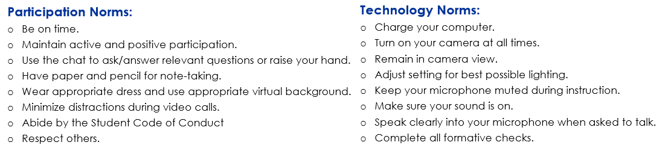
Homework: Homework will be checked for completion. Any late homework assignments must be completed and submitted by 8 AM on the day of the test – all late homework will be accepted for 50% credit. Please be aware that most homework assignments are to be completed through DeltaMath.
Course Materials:
· Composition Notebook · Calculator (see below) · Additional Notebook Paper
· Pencils and Erasers · Binder or Folder · Highlighters (optional)
Calculators: The following calculators are recommended for this course: TI-83, TI-84, and
TI-36X Pro. If you do not have access to one of these calculators, please utilize the free online graphing calculator and scientific calculator through Desmos.
Cheating: Cheating will NOT be tolerated. Cheating includes copying/sharing work, communicating with others during a quiz/test, using a calculator/app/website when it is not allowed. If it is determined that you have cheated, you will receive a zero on the assignment, your parents will be called, and you will be given a U for conduct. When you submit any assignment, you are saying that it is your own work and that it has not been copied from another person, a website, or an app (such as Photomath). Apps and websites typically have unique ways of solving problems which are easy to recognize by teachers.
Help Sessions: Now more than ever, it is important that you communicate when you have questions or need additional instruction. Small group and individual tutoring sessions can be scheduled during virtual office hours.
Remind: All students and at least 1 parent should sign up for the class Remind. To sign up, please text @387kf68 to 81010.

